**STORED PROCEDURES**

1. **RETURN PRODUCT ID:** (get_productid) 🡪 Procedure which will return the productid based on PO number and orderitem id

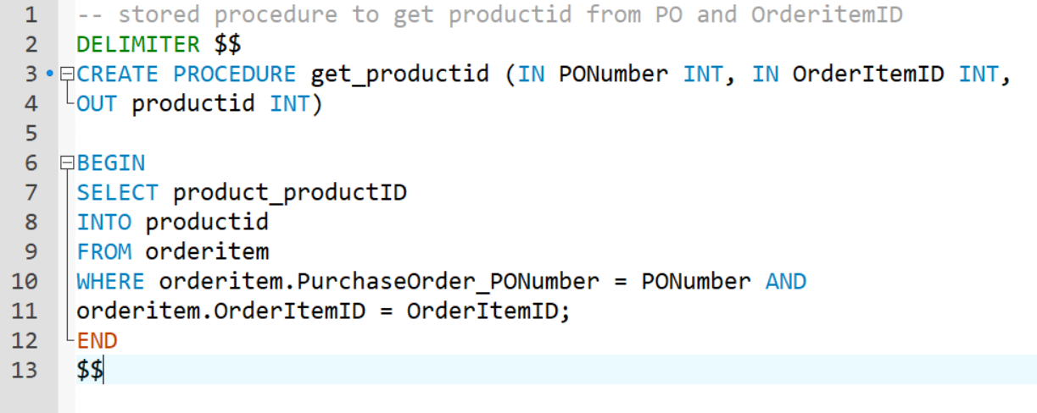

1. **CREATE TRACKING:** (create_tracking) 🡪 procedure to create tracking ID for given shipment (for PO)

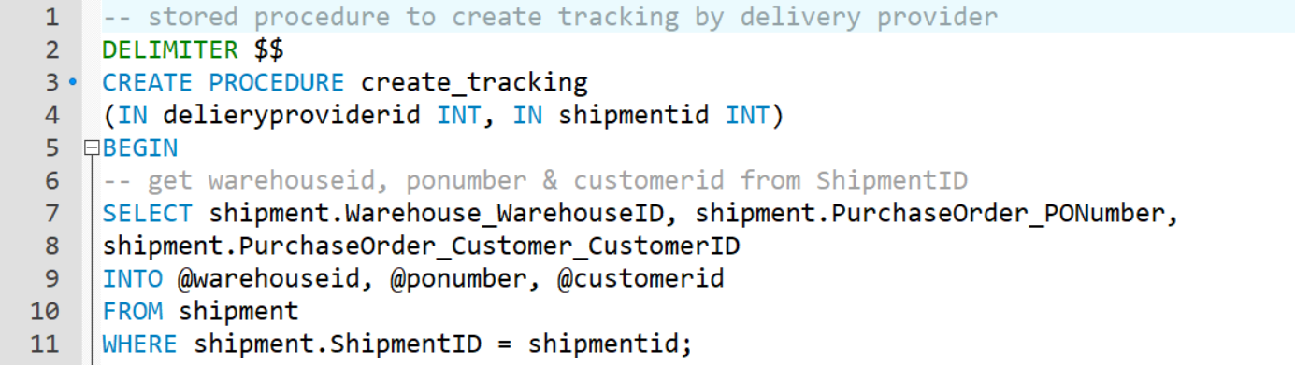

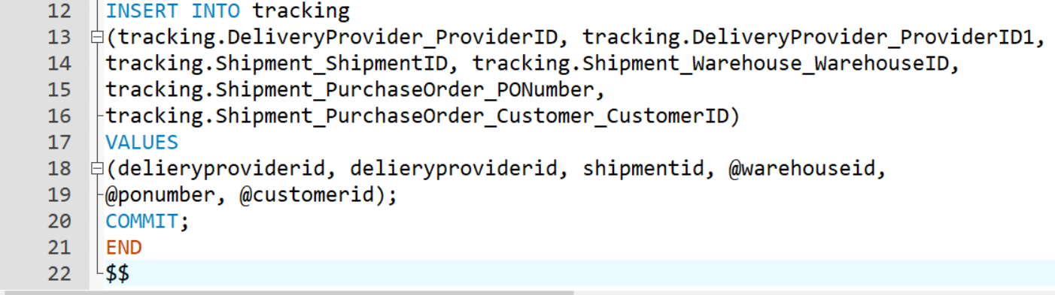

1. **TRACKING STATUS:** (create_tracking_status) 🡪 stored procedure to create tracking status for given tracking id

It will take TrackingID, State and ZIP to deliver the shipment

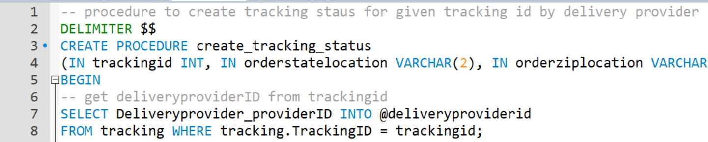

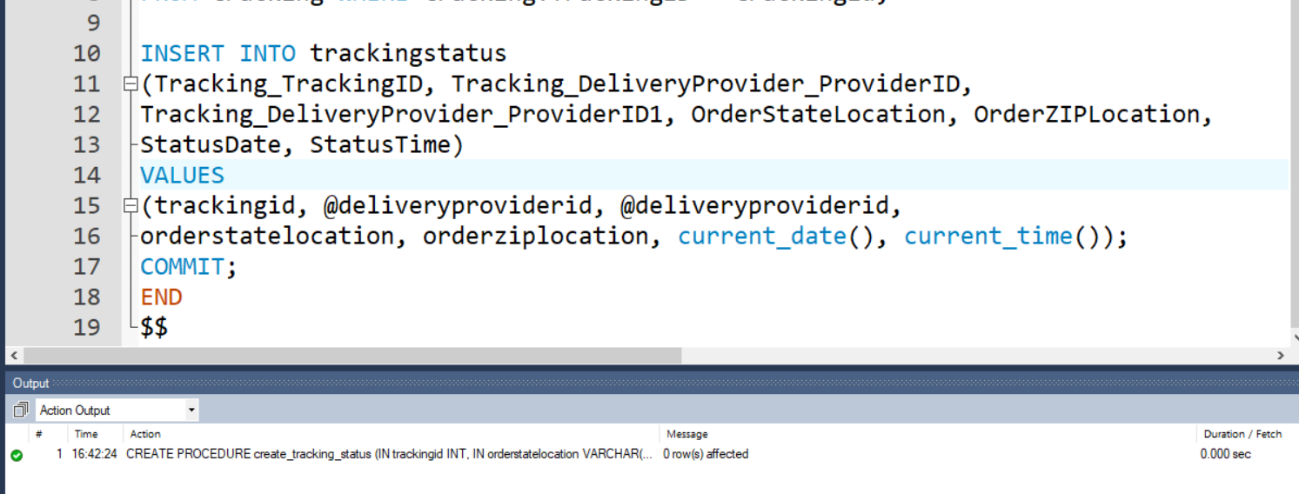

1. **GIFTCARD BALANCE:** (get_giftcard_balance) 🡪 procedure to display balance of **‘Active’** gift cards

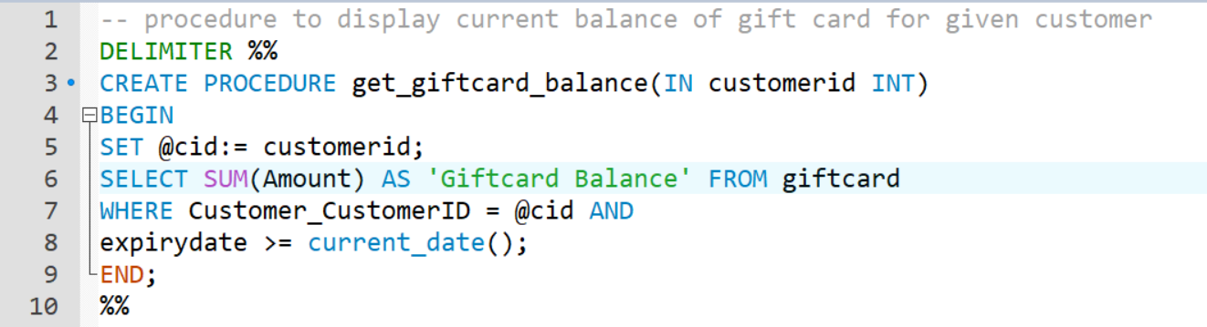

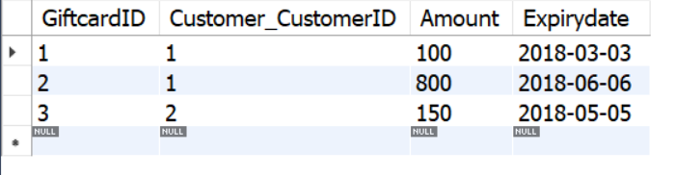

Calling the procedure gives below output

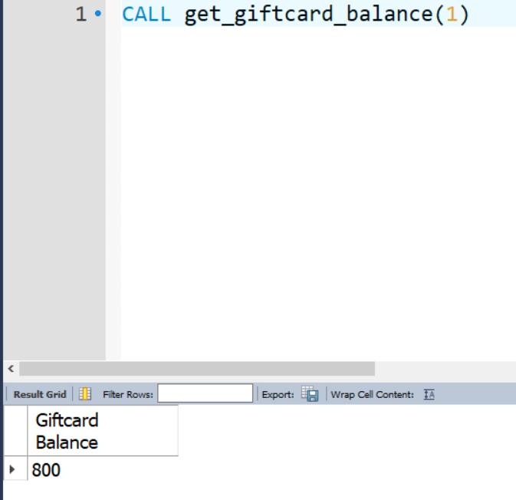

1. **GET ALL ORDERS:** (get_all_orders) 🡪 procedure to display list of all orders for given customer

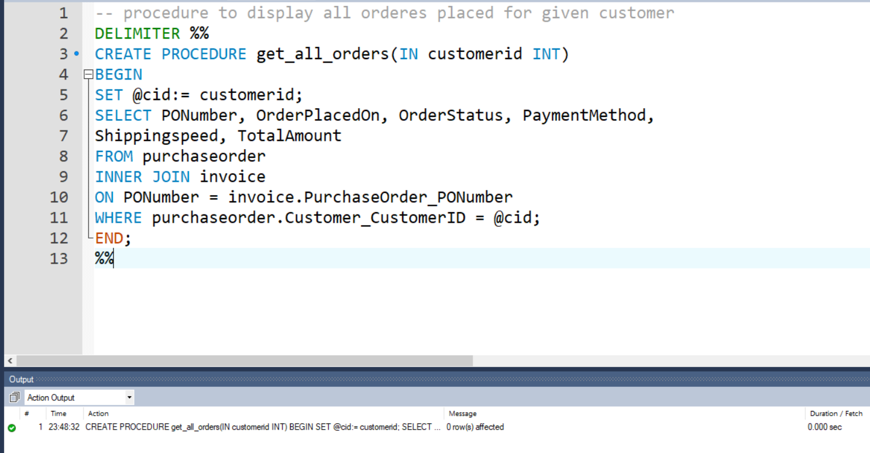

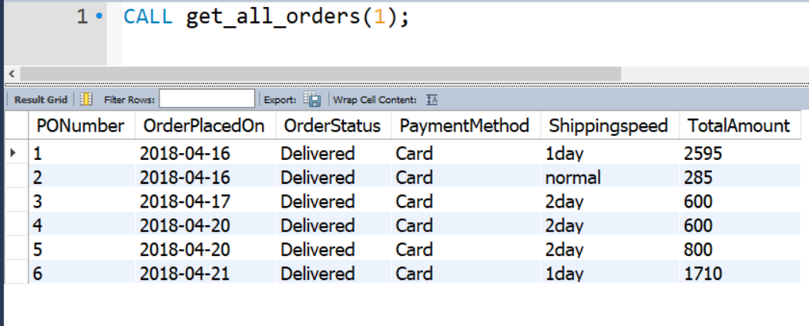

1. **CURRENT ORDER LOCATION:** (get_order_location) 🡪 procedure to check the order location (provide PO number)

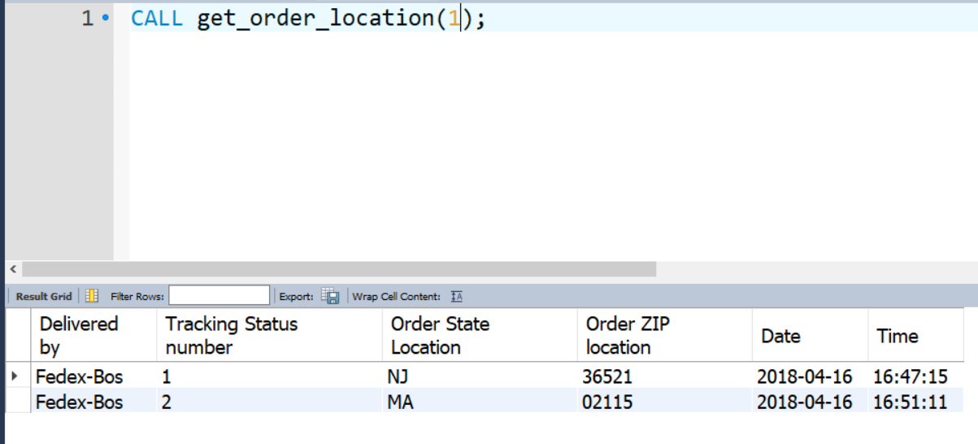

1. **TOTAL PRODUCTS SOLD:** (total_products_sold_for_current_month) 🡪 takes supplier id as input parameter and displays list of all products sold by supplier in **‘current’** month

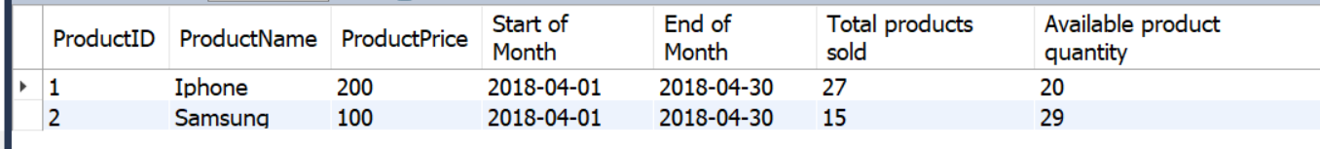

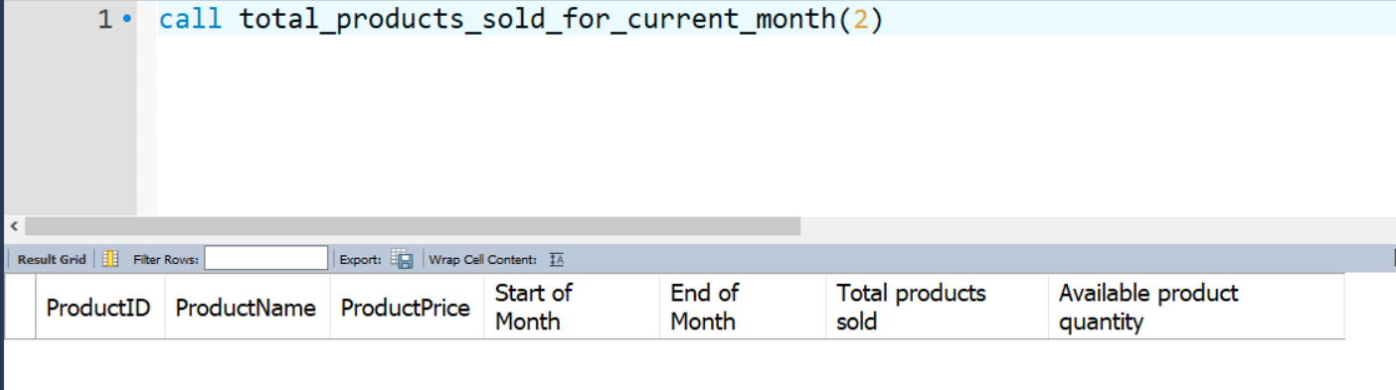

1. **TOTAL BUSINESS BY SUPPLIER:** (get_total_business_on_days) 🡪 procedure which will return the business done by supplier during given timeframe.

